***FOR IMMEDIATE RELEASE***

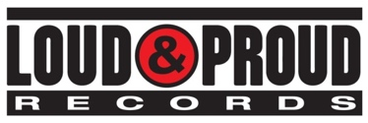

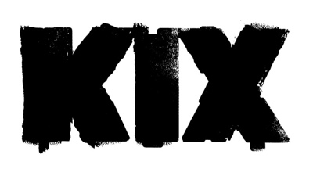

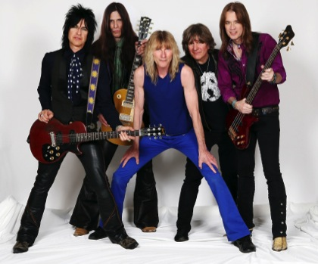

***CAN’T STOP THE SHOW: THE RETURN OF KIX* - A DOCUMENTARY**

**TWO-DISC DVD/CD SET TO BE RELEASED OCTOBER 21, 2016**

**DVD INCLUDES THE MAKING OF *ROCK YOUR FACE OFF* - KIX’S FIRST NEW MUSIC IN 20 YEARS, INTERVIEWS WITH THE BAND, producer Taylor Rhodes, NOTABLE ROCK ARTISTS AND key rock music industry figures**

**NEW YORK, NY (SEPTEMBER 8, 2016)** - Platinum-selling Maryland hard rock icons, **KIX** will release

***CAN’T STOP THE SHOW: THE RETURN OF KIX***, a **two-disc DVD/CD** set, **October 21, 2016** on **Loud & Proud Records**. The 71-minute film is an in-depth look into KIX’s decision to record their first new album, **2014’s *Rock Your Face Off****,* in almost 20 years.

The DVD - **WATCH THE TRAILER** [**HERE**](https://www.youtube.com/watch?v=yU8SfNyb5OE) - also features the making of the album from bassist Mark Schenker’s studio, interviews with the band as well as notable rock artists such as **Nuno Bettencourt** of **Extreme**, **Lzzy Hale** of **Halestorm**, **Jeff LaBar** of **Cinderella, Share Ross** of **Vixen, Shannon Larkin** of **Godsmack**, and more, key music industry veterans such as radio personality **Eddie Trunk, Don Jamieson** of ***That Metal Show*** on **VH1 Classic** as well as **Luc Carl**and **Keith Roth** of **Sirius/XM**. It also includes a rare appearance by producer **Taylor Rhodes** (Aerosmith, Ozzy Osbourne, KIX’s *Hot Wire*).

The CD, ***CAN’T STOP THE SHOW (LIVE)*** offers never-before-released live KIX tracks recorded over the last three years. A bonus KIX logo sticker is inside the first manufacturing run, a special treat for KIX fans around the world, and each band member offers his own special contribution to the package’s booklet including vocalist Steve Whiteman’s rigorous exercise routine, cartoons by guitarist Brian “Damage” Forsythe, an essay by bassist Mark Schenker, a gear rundown by guitarist Ronnie “10/10” Younkins and a favorite recipe from drummer Jimmy Chalfant, aka “Chef Chocolate.”

“KIX is proud of the band's legacy, but equally proud of our new chapter,” says Schenker. “We had an opportunity to work with some great film makers, so we just let the cameras roll everywhere, and had so much fun putting the project together. There was a true outpouring of love and admiration from our fans and our peers after the release of *Rock Your Face Off* and luckily, we had documented the recording sessions on film. Now we are excited to share the process of making the new album with our loyal fans.  KIX thanks everyone involved and hopes everyone loves it as much as we loved making it!”

In 2014, KIX released their seventh full-length album, *Rock Your Face Off* (Loud & Proud Records) their first studio effort since 1995’s *Show Business*. The album debuted at #1 on Amazon’s “Hard Rock and Metal “chart, in the Top 50 on *Billboard’s* “Top 200 Albums” chart, #5 on the “Independent Albums “chart, #11 on the “Top Internet “chart, #17 on the “Top Rock Albums” chart, #27 on the “Indy/Small Chain Core Stores” chart and #33 on the “Physical” chart. It also garnered rave reviews from publications such as ***Stereogum*** who said, “KIX have made an album with all the spirit and joy and craftsmanship that they always brought, an album with a hooks-per-minute ratio enough to grab you even if you never heard of them before reading this review. The band plays with a sense of rhythmic push-pull that reminds you that people used to *dance* to this stuff, and that they still could, if they were so inclined…Its mere existence is an inspirational thing, and it’s a reminder that sometimes exploring new musical space isn’t the most important thing. Sometimes, *songs* are the most important thing.”

KIX will be performing select shows for the rest of the year, including a home town release event show in Baltimore, MD at Rams Head Live on **September 24**. All tour dates can be found on the band’s website [HERE](http://www.kixband.com/tour/). Pre-order ***CAN’T STOP THE SHOW: THE RETURN OF KIX*** through Amazon [HERE](http://lnp.io/2bVSLWP).



***CAN’T STOP THE SHOW: THE RETURN OF KIX* CD TRACK LISTING*:***

1.  Wheels In Motion (Live)

2.  Rock Your Face Off (Live)

3.  Cold Shower (Live)

4.  Mean Miss Adventure (Live)

5.  You’re Gone (Live)

6.  Cold Blood (Live)

7.  Can’t Stop The Show (Live)

8.  Girl Money (Live)

9.  Love Me With Your Top Down (Live)

10.  Blow My Fuse (Live)

11.  Love Pollution (Live at Sirius/XM)

12.  Midnite Dynamite (Live at Sirius/XM)

**DVD INTERVIEWS:**

Eddie Trunk (radio personality)

Taylor Rhodes (producer)

Nuno Bettencourt (Extreme)

Lzzy Hale (Halestorm)

Luc Carl (Sirius/XM)

Keith Roth (Sirius/XM)

Share Ross (Vixen)

Shannon Larkin (Godsmack/Wrathchild America)

Jeff LaBar (Cinderella)

Don Jamieson (Host of *That Metal Show* on VH1 Classic)

Jaime St James (Black N Blue/Warrant)

Chip Z'Nuff (Enuff Z'Nuff)

Alex Kayne (L'Amour)

Kevin Butler (Hammerjacks)

Steve Kicas (Hammerjacks)

Scott Spelbring (producer)

For More Information, Please Contact:

Julie Lichtenstein / 37-media

[Julie@37-media.com](mailto:Julie@37-media.com)

**KIX**

[Website](http://www.kix-band.com/)  
[Facebook](http://www.facebook.com/OfficialKIX)  
[Twitter](http://www.twitter.com/KIXtheband)

[Loud & Proud Records](http://www.loudandproudrecords.com/)

**# # #**