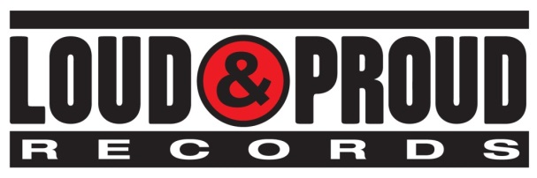



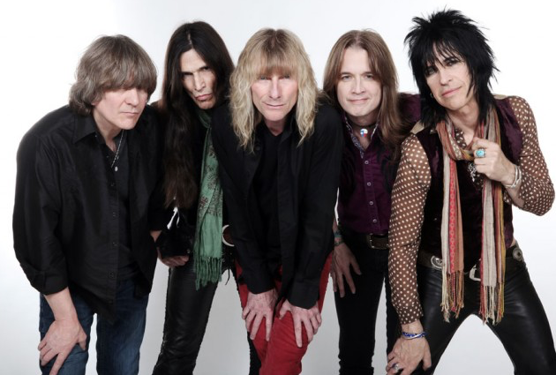

L 🡪 R: Jimmy "Chocolate" Chalfant [drums], Ronnie "10/10" Younkins [guitar], Steve Whiteman [vocals], Mark Schenker [bass], Brian "Damage" Forsythe [guitar]

Photo Credit: Mark Weiss

On the 30th Anniversary of their platinum album, *Blow My Fuse*, Maryland hard rock icons, KIX release *Fuse 30 Reblown - 30th Anniversary Special Edition* two-disc set, on September 21, 2018 –exactly 30 years after *Blow My Fuse’s* original September 19, 1988 release date.

*Fuse 30 Reblown* Disc #1 features a raw and impactful remix by Beau Hill (Alice Cooper, Ratt, Warrant, KIX) of *Blow My Fuse*, and a top-notch mastering job by Jay Frigoletto (Alice in Chains, Tesla). The remix of the original master tapes brings forth characteristics of the album that the band feels had been missing, including the approach to the unique guitar sounds of Brian “Damage” Forsythe and Ronnie “10/10” Younkins. “The performances come out so much better in this remix,” says drummer Jimmy “Chocolate” Chalfant. “All the crap’s taken off of it, and you can really hear the band playing, rather than the reverb playing.”

“It’s like getting cataracts removed,” quips vocalist Steve Whiteman. “The remix clears it right up.”

Never-before-released demos of all 10 tracks, recorded in the early to mid 1980’s, are on Disc #2 and prove how well-prepared KIX were prior to entering the studio to record their albums.

Upon announcing the release of *Fuse 30 Reblown* in May of 2018, KIX began performing *Blow My Fuse* in its entirety in their live set. The band admits that it’s a challenge to play those songs live. Brian Forsythe explains, “Some of those songs are not easy to play. For example, ‘Piece of the Pie’ was never actually played all the way through live. We recorded it in sections in the studio.” Fans have received the set well. “It’s a different vibe from a normal KIX show, to watch fans get into us playing the entire album in order,” adds bassist Mark Schenker. “It changes everything when fans hear those songs in the order of the album. It takes them back to when they were listening to the cassette in their cars, from beginning to end.”

___

When the members of KIX traveled to Los Angeles in early 1988 to begin recording *Blow My Fuse*, they knew that the album could make or break the band. And sure enough, upon its release in September of 1988, *Blow My Fuse* outperformed its predecessors. A video for the song “Cold Blood” dominated MTV’s popular “Dial MTV” program for so long that the network was forced to change the show’s rules to knock KIX out of the top slot. “We had diehard fans who felt that our success was long overdue,” says Whiteman. “They all felt compelled to call in and vote every damn day.”

*Blow My Fuse* was certified Gold before “Don’t Close Your Eyes” was released. The band’s sole Top 40 hit peaked at #11 on *Billboard’s* Hot 100 chart, which propelled the album to platinum status. *Blow My Fuse* cemented KIX as one of the Eighties’ preeminent hard rock acts. “That album gave us a legacy. And something to stand on,” says Whiteman. “It’s the reason we were able to come back and still do this. I’m convinced of that.”

KIX gracefully eased back into the public consciousness in 2008. After sold out hometown gigs, the quintet hit the stage at *Rocklahoma* in front of over 20,000 people, venturing out of the Mid-Atlantic for the first time in 13 years. Delivering a triumphant set alongside the likes of Sammy Hagar and Alice Cooper, they left their mark on old and new fans alike. After capturing their fiery reunion on 2012's *Live in Baltimore* CD & DVD, the members agreed to enter the studio once again for 2014’s *Rock Your Face Off* (#48 on *Billboard’s* Top 200 Albums, #1 Amazon Hard Rock and Metal Albums, #5 Independent Albums, #11 Top Internet, #17 Top Rock Albums),

followed by the documentary *Can’t Stop The Show: The Return Of KIX,* which reached #1 on Billboard’s Music Video Sales chart.

"In many ways, this is for the KIX diehards as much as it is for us," Forsythe concludes. "When we started doing this again, tons of fans came out of the woodwork. They'd show up with their kids, and it was just incredible to see. We had to deliver for them."

[www.kix-band.com](http://www.kix-band.com)  
[www.facebook.com/OfficialKIX](http://www.facebook.com/OfficialKIX)  
[www.twitter.com/KIXtheband](http://www.twitter.com/KIXtheband)

[www.loudandproudrecords.com](http://www.loudandproudrecords.com)