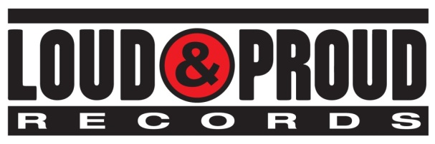 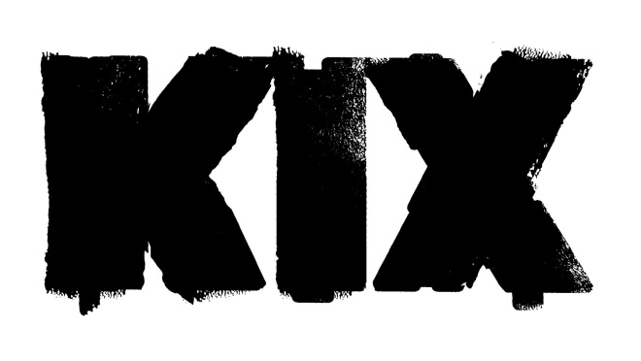

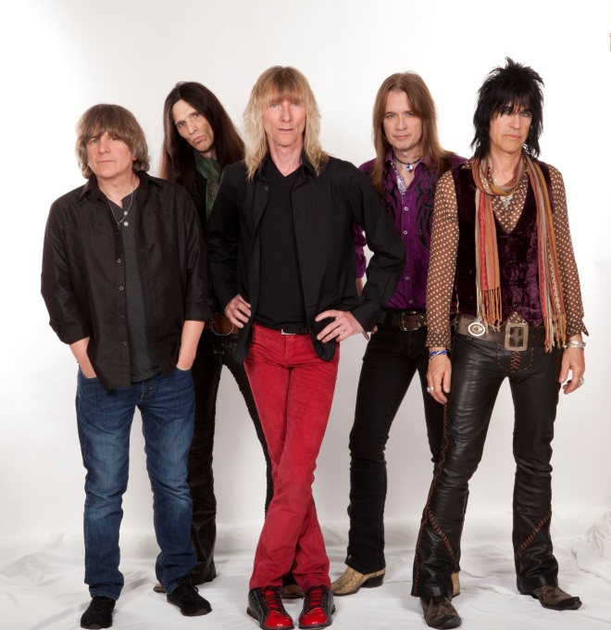

**KIX’S ‘ROCK YOUR FACE OFF’ ALBUM**

**CRACKS BILLBOARD’S TOP 50 ITS FIRST WEEK OUT**

**WITH FIRST STUDIO ALBUM IN ALMOST TWO DECADES**

**August 13, 2014** – Fans of KIX-- Steve Whiteman (vocals), Brian "Damage" Forsythe (guitar), Ronnie "10/10" Younkins (guitar), Jimmy "Chocolate" Chalfant (drums), Mark Schenker (bass)—have waited almost two decades for new music. Now that their seventh album was released August 5 on Loud & Proud Records, their unwavering and undying support has landed ROCK YOUR FACE OFF in the Top 50 on Billboard’s “Top 200 Albums” chart.

Elsewhere in Billboard, in addition to the #48 chart debut, ROCK YOUR FACE OFF debuted at #5 on the Independent Albums chart, #11 on the Top Internet chart, #17 on the Top Rock Albums chart, #27 on the Indy/Small Chain Core Stores chart and #33 on the Physical chart. It also debuted at #1 on Amazon’s Hard Rock and Metal chart.

Rave reviews have been pouring in since ROCK YOUR FACE OFF was released:

“KIX have made an album with all the spirit and joy and craftsmanship that they always brought, an album with a hooks-per-minute ratio enough to grab you even if you never heard of them before reading this review. The band plays with a sense of rhythmic push-pull that reminds you that people used to dance to this stuff, and that they still could, if they were so inclined. “Rollin’ In Honey,” about having so much sex that you feel like you’re drowning, rides cowbells and backing-vocal chants that push the song close to bubblegum-disco territory...Nearly every song has oh whoa whoa backing vocals that will get stuck in your head for hours. All of it is delirious and catchy, and it proudly flaunts its out-of-fashion party-hard spirit. It’s glittering trash, made by guys in their fifties who probably hold down day jobs these days and who have no business making this vigorous and fun anymore. Its mere existence is an inspirational thing, and it’s a reminder that sometimes exploring new musical space isn’t the most important thing. Sometimes, songs are the most important thing.” (Stereogum.com)

“The album, which was produced by Taylor Rhodes, is a collection of blues-inspired rock that combines catchy hooks and tasty riffs with the inspired musicianship and party atmosphere KIX are known for.” (GuitarWorld.com)

“...it is good to see that KIX has stuck to their signature style in your face AC/DC sound...In the vein of BLOW YOUR FUSE the up tempo beat of the band never diminishes and keeps on rolling. The tightness of the band is evident...ROCK YOUR FACE OFF is the perfect summertime record. Crank it up to ten and roll your top down, as the pride of Maryland shows the country how to rock East Coast style.” (Hardrockhaven.net)

Check out KIX at any of the following stops:

**DATE CITY VENUE**

Sat 8/16 Greencastle, PA Greencastle Legion Grounds

Sat 9/13 Berlin, MD Soundwave Festival at Airlift Acres

Sat 9/20 Baltimore, MD Rams Head Live

Sat 10/25 Camp Hill, PA Radisson Convention Center

Sat 12/20 Baltimore, MD Rams Head Live (KIXmas)

About Loud & Proud Records

Loud & Proud Records is an independent record label founded in 2007 by Tom Lipsky whose mission is to provide a true and transparent partnership between artists and their record label.  Loud & Proud’s current roster includes five-time Emmy® Award winning actor and musician Jonathan Jackson and his band Enation, multi-platinum alternative band Flyleaf, rock supergroup The Winery Dogs, renowned jam band The String Cheese Incident, multi-platinum country artists BlackHawk, Seattle’s alternative Walking Papers, critically-acclaimed singer/songwriter Willie Nile and powerhouse rockers KIX.  Labels under Lipsky's direction in the past, including CMC International, Sanctuary Records Group and a joint-venture with Roadrunner Records, were responsible for releases by such renowned artists as Neil Young, Rush, Lynyrd Skynyrd, KISS, Robert Plant, Rob Zombie, Morrissey, Lenny Kravitz, Iron Maiden, The Allman Brothers Band and more.  Loud & Proud Records is distributed in the U.S. and Canada by RED, a division of Sony Music Entertainment, and in the rest of the world by earMUSIC/Edel AG. Loud & Proud Records is a registered trademark of Lipsky Music, LLC.

[www.kix-band.com](http://www.kix-band.com)  
[www.facebook.com/OfficialKIX](http://www.facebook.com/OfficialKIX)  
[www.twitter.com/KIXtheband](http://www.twitter.com/KIXtheband)

[www.loudandproudrecords.com](http://www.loudandproudrecords.com)

[www.facebook.com/LoudandProudRecords](http://www.facebook.com/LoudandProudRecords)

[www.twitter.com/LoudProudLabel](http://www.twitter.com/LoudProudLabel)

###