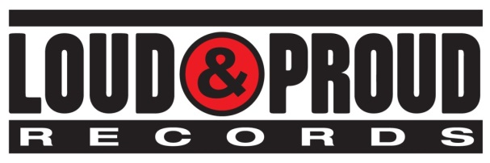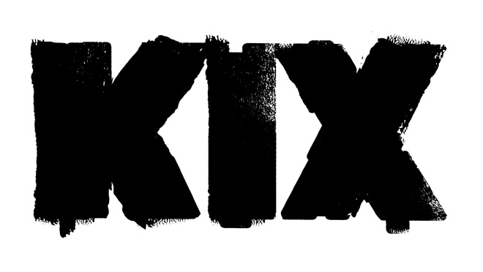

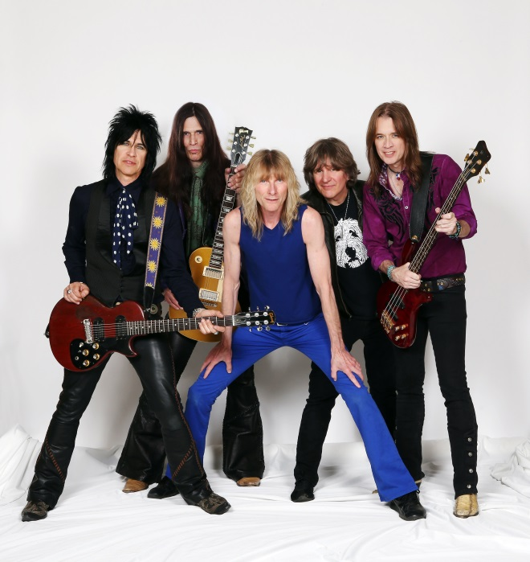

**KIX**

**IS READY TO**

**‘ROCK YOUR FACE OFF’**

**WITH NEW ALBUM,**

**THEIR FIRST IN TWO DECADES,**

**DUE OUT AUGUST 5 ON LOUD & PROUD RECORDS**

June 18, 2014 -- For KIX, not recording any new music for two decades has been far too long. Fans have made it known for years that they want new music. And now, the time has finally come. The Maryland band is primed and ready to ROCK YOUR FACE OFF with their seventh new album set for release August 5 on Loud & Proud Records. It’s everything fans know and love them for: a raucous, roaring and real display of rock 'n' roll. The first single, “Love Me With Your Top Down,” will be released to radio and online retail outlets later this month. Eddie Trunk will exclusively world premiere the song during his “Friday Night Rocks” radio show originating from Q104.3 (heard in New York City, Long Island, NJ and CT) this Friday, June 20 from 11pm-2am ET. It will then air via his numerous North American syndicated affiliates on Saturday, June 20 and he’ll play it on Monday, June 23 during his “Trunk Nation with Eddie Trunk” show that airs on SiriusXM’s “Hair Nation” channel (39) at 3pm PT/6pm ET.

As guitarist Brian "Damage" Forsythe explains, “When we first played ‘Love Me With Your Top Down’ live just a few months ago, it went over like gangbusters with the fans.  It’s a catchy little tune with classic KIX flavor, a perfect choice for the first taste of the record.”

What makes the new album even more exciting and anticipated is that it features most of the band’s original line-up: Steve Whiteman (vocals), Brian "Damage" Forsythe (guitar), Ronnie "10/10" Younkins (guitar), Jimmy "Chocolate" Chalfant (drums), with the exception of Mark Schenker (bass).

With ROCK YOUR FACE OFF, KIX stirs up their truest statement to date in 2014. "It's still hot women, fast cars, and great moments," concludes Whiteman. "I want everybody to end up on their feet, whether they’re working out or stuck in rush hour traffic. This is a release, something to lift your spirits when you need it. You can party to this one."

KIX gracefully eased back into the public consciousness in 2008. After sold out hometown gigs, the quintet hit the stage at Rocklahoma in front of over 20,000 people, venturing out of the Mid-Atlantic for the first time in 13 years. The band was hailed by many music websites and attendees as *“*Best Performance*”* at the festival, where they played alongside Sammy Hagar, Alice Cooper, Tesla, Queesryche, Ratt, and more. After capturing their fiery reunion on 2012's LIVE IN BALTIMORE CD & DVD, the band agreed to enter the studio once again.

"In many ways, this is for the KIX diehards as much as it is for us," guitarist Brian Forsythe explains. "When we started doing this again, tons of fans came out of the woodwork. They'd show up with their kids, and it was just incredible to see. We had to deliver for them."

In order to deliver, the band enlisted the talents of producer Taylor Rhodes (Aerosmith, Ozzy Osbourne), with whom they had last collaborated on 1991's HOT WIRE. Also, for the first time in the group's history, each member contributed to the writing process, fostering an extremely creative and free environment in the studio. A new dawn commenced as they simultaneously harnessed their classic spirit.

"It was more free-flowing because everybody got to write and come up with ideas," says singer Steve Whiteman. "We encouraged this new freedom within the creative process."

Here’s the complete track listing of ROCK YOUR FACE OFF:

1. Wheels In Motion

2. You’re Gone

3. Can’t Stop The Show

4. Rollin’ In Honey

5. Rock Your Face Off

6. All The Right Things

7. Dirty Girls

8. Inside Outside Inn

9. Mean Miss Adventure

10. Love Me With Your Top Down

11. Tail On The Wag

12. Rock & Roll Showdown

Stay tuned for new tour news, but check them out at any of the following stops in the meantime:

**DATE CITY VENUE**

Sat 6/21 Idaho Falls, ID Rock The Falls

Thu 7/10 Hughesville, PA Lycoming County Fair

Fri 7/25 Royalton, MN Halfway Jam

Thu 7/31 Leemore, CA Tachi Palace Casino

Sat 8/2 Leonardtown, MD Southern Maryland Brew & BBQ Fest

Sat 8/16 Greencastle, PA Greencastle Legion Grounds

Sat 9/13 Berlin, MD Soundwave Festival at Airlift Acres

Sat 9/20 Baltimore, MD Rams Head Live

Sat 10/25 Camp Hill, PA Radisson Convention Center

Sat 12/20 Baltimore, MD Rams Head Live (KIXmas)

About Loud & Proud Records

Loud & Proud Records is an independent record label founded in 2007 by Tom Lipsky whose mission is to provide a true and transparent partnership between artists and their record label.  Labels under Lipsky's direction in the past, including CMC International, Sanctuary Records Group and a joint-venture with Roadrunner Records, were responsible for new releases by Neil Young, Rush, Lynyrd Skynyrd, KISS, Robert Plant, Rob Zombie, Morrissey, Lenny Kravitz, Iron Maiden, The Allman Brothers Band and more.  Loud & Proud’s current roster includes five-time Emmy® Award winning actor and musician Jonathan Jackson and his band Enation, multi-platinum alternative band Flyleaf, supergroup rock band The Winery Dogs, renowned jam band The String Cheese Incident, multi-platinum country artists BlackHawk, Seattle’s alternative Walking Papers, critically-acclaimed singer/songwriter Willie Nile and powerhouse rockers KIX.  Loud & Proud Records is distributed in the U.S. and Canada by RED, a division of Sony Music Entertainment, and in the rest of the world by earMUSIC/Edel AG. Loud & Proud Records is a registered trademark of Lipsky Music, LLC.

[www.kix-band.com](http://www.kix-band.com)  
[www.facebook.com/OfficialKIX](http://www.facebook.com/OfficialKIX)  
[www.twitter.com/KIXtheband](http://www.twitter.com/KIXtheband)

[www.loudandproudrecords.com](http://www.loudandproudrecords.com)

[www.facebook.com/LoudandProudRecords](http://www.facebook.com/LoudandProudRecords)

[www.twitter.com/LoudProudLabel](http://www.twitter.com/LoudProudLabel)

###

CONTACT:

Amanda Cagan

ABC PR

818 990 6876

[Amanda@abc-pr.om](mailto:Amanda@abc-pr.om)